Print on heavy stock
Fold in half vertically
Cut along the solid line

 | 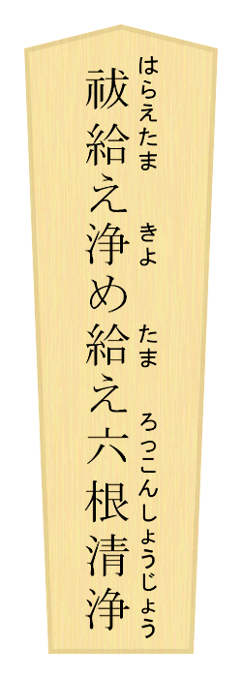 |  |  | 

shaku provided courtesy of shi-yaku-jin no hokora

